ENCON PRODUCTION
File name: xampp_new/htdocs/Production
DB: wetap_encon_production
Modules:
Select Company Site 101
- Carbon Fiber Drive Shaft (Internal / External) 101
- FRP Header Pipe (Internal / External) 101
- FRP Clamp (Internal / External) 101

Select Company Site 74
- HUB (Internal / External)

Select Company Site Bharat Aluminium

- Blade Modifications (Internal / External)
Note:
tbl_indent and tbl_indent_details has all type of indent root data which is identify uniquely.
- Carbon Fiber Driver Shaft
Tables:
- tbl_indent
- tbl_indent_details
- tbl_indent_carbon_fiber_drive_shift
- tbl_carbon_fiber_drive_shaft_specifications
- tbl_indent_carbon_fiber_drive_shaft_received_orders
- tbl_indent_carbon_fiber_drive_shaft_received_order_status
- tbl_indent_carbon_fiber_drive_shaft_received_order_status_detail
- tbl_cfds_stage_master

FUNCTIONALITY:
After Create CFDS Indent it will be show into Internal CFDS Listing (if External created it must be lock for show internal listing).
After Create Indent, go on edit button and add order qty to create order which is create into Carbon Fiber Driver Shaft received orders
In received orders we easily manage order stages by click on Design Selection stage column td.
There is also view button to check order details with stage data.

- FRP Header Pipe
Tables:
- tbl_indent
- tbl_indent_details
- tbl_indent_frp_header_pipe
- tbl_frp_header_pipe_specifications
- tbl_indent_frp_header_pipe_received_orders
- tbl_indent_frp_header_pipe_received_order_status
- tbl_indent_frp_header_pipe_received_order_status_detail
- tbl_frp_header_pipe_stage_master
FUNCTIONALITY:
After Create FRP Header Pipe Indent it will be show into Internal FRP Header Pipe Listing (if External created it must be lock for show internal listing).
After Create Indent, go on edit button and add order qty to create order which is create into FRP Header Pipe received orders
In received orders we easily manage order stages by click on Design Selection stage column td.
There is also view button to check order details with stage data.

- FRP Clamp Indent
Tables:
- tbl_indent
- tbl_indent_details
- tbl_indent_frp_clamp
- tbl_frp_clamp_specifications
- tbl_indent_frp_clamp_received_orders
- tbl_indent_frp_clamp_received_order_status
- tbl_indent_frp_clamp_received_order_status_detail
- tbl_frp_clamp_stage_master

FUNCTIONALITY:
After Create FRP Clamp Indent it will be show into Internal FRP Clamp Listing (if External created it must be lock for show internal listing).
After Create Indent, go on edit button and add order qty to create order which is create into FRP Clamp received orders
In received orders we easily manage order stages by click on Under Selection stage column td.
There is also view button to check order details with stage data.

Select Company Site 74
- HUB
Tables:
- tbl_indent
- tbl_indent_details
- tbl_indent_hub
- tbl_indent_hub_received_orders
- tbl_indent_hub_received_order_status
- tbl_indent_hub_received_order_status_detail
- tbl_frp_hub_stage_master
FUNCTIONALITY:
After Create Hub Indent it will be show into Internal Hub Listing (if External created it must be lock for show internal listing).
After Create Indent, go on edit button and add order qty to create order which is create into Hub received orders
In received orders we easily manage order stages by click on edit button.
There is also view button to check order details with stage data.
Masters
1 Plate OD HUB
tbl_master_indent_hub_plate_od
2 HUB Thickness
tbl_master_indent_hub_thickness

BLADE Functionality:

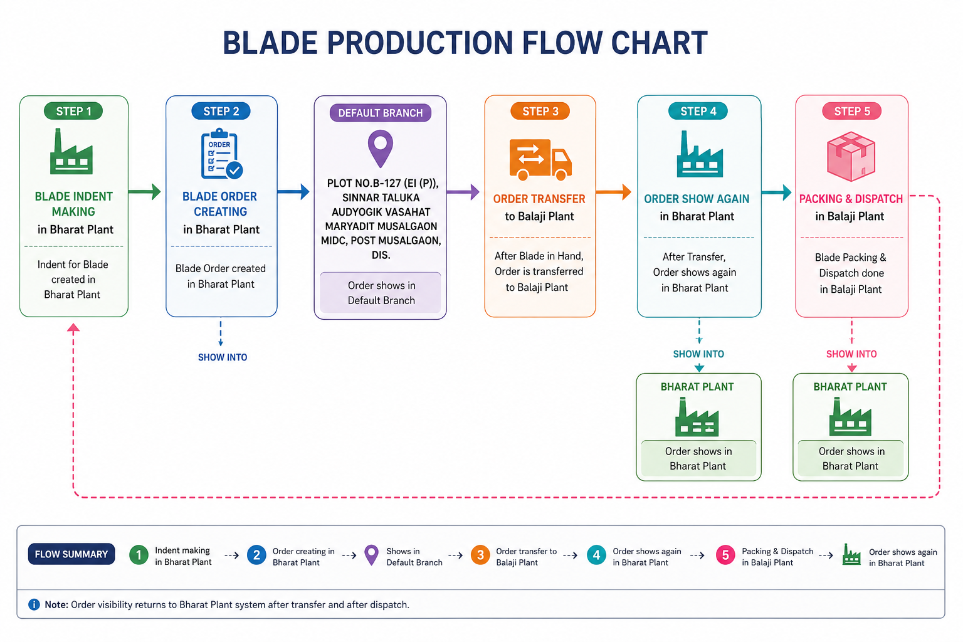
There is blade which is assemble with multiple hardware’s like clamp and hub. Below is the flow chart for blade for transfer order and creation flow.

